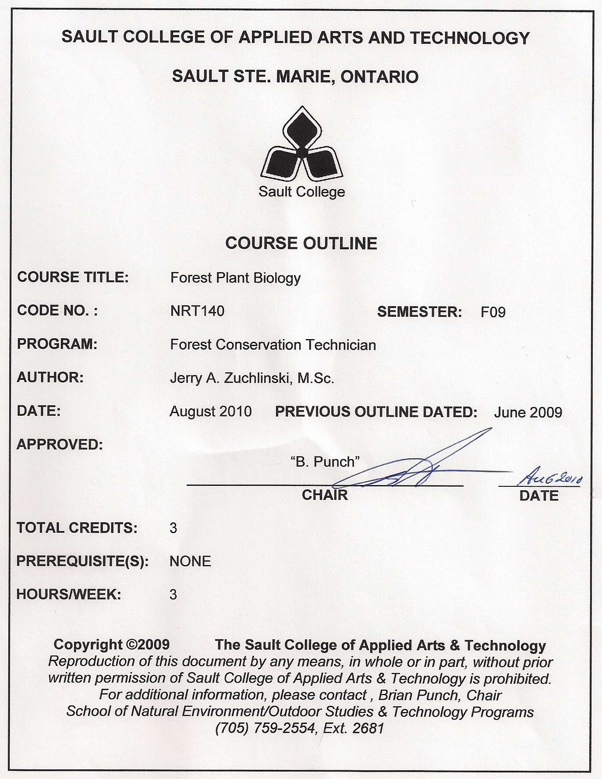

I. | COURSE DESCRIPTION:  This course provides the student with a practical understanding of the classification, structure and functioning of plants in general with special consideration for woody plants. The concepts presented in this course will have direct application in a number of courses in the Forest Conservation Technician Program

II. | LEARNING OUTCOMES AND ELEMENTS OF THE PERFORMANCE:
 | Upon successful completion of this course, the student will demonstrate the ability to:
 | 1. | Describe what a species is and how all species relate in their evolutionary history.
Potential Elements of the Performance:
- apply the classification List various characteristics used to practically distinguish different species
- Describe and use the binomial system of classification
- Explain phylogeny and system
 | 2. | Describe the structure and functioning of a plant cell
Potential Elements of the Performance:
- List and describe the function and interactions of the following cell components: cell wall, cell membrane, nucleus, nucleolus, chloroplast, mitochondria, ribosomes, golgi apparatus, vacuoles and endoplasmic reticulum
- Describe the structural roles of carbohydrates, lipids, amino acids and nucleic acids in cells

 | 3. | Describe the anatomy, function and inter-relationships of specified structures of a plant.
Potential Elements of the Performance:
- Describe cells and tissues of leaves, stems, and roots
- Distinguish by anatomical features between flowering plants and gymnosperms and between monocots and dicots
- Recognize cells and tissues of leaves, stems and roots from microscopic slides

 | 4.
Potential Elements of the Performance:
- Describe the processes involved in photosynthesis
- Describe the processes involved in respiration
- Describe the processes involved in transpiration
- Describe the processes involved in water and nutrient uptake

 | 5. | Describe plant growth process
Potential Elements of the Performance:
- Describe the various meristematic regions in plant including vascular cambium, cork cambium and apical meristems
- Describe the roles of auxins and giberellins in plant growth
- Distinguish between primary and secondary growth
- Describe the process of annual growth in woody plants

 | 6. | Describe reproductive processes in plants
Potential Elements of the Performance:
- differentiate between sexual and asexual reproduction
- list and give examples of 6 different vegetative methods of reproduction
- distinguish between haploid and diploid conditions, gametophyte and sporophyte generations, spores and seeds

7. Describe life cycles of various plant groups

Potential Elements of the Performance:

- distinguish between different stages in the life cycles of ferns, mosses, club mosses, conifers and flowering plants
- draw from microscope slides specified life stages

III. | TOPICS:
 | 1. | Classification of plants
 | 2. | The plant cell
 | 3. | Plant structure
 | 4. | Metabolic processes
 | 5. | Plant growth
 | 6. | Plant reproduction and life cycles

IV. | REQUIRED RESOURCES/TEXTS/MATERIALS:  Stern, K.A.. Introductory Plant Biology. Wm. C. Brown Publishers. 537pp

V. | EVALUATION PROCESS/GRADING SYSTEM:  Mid-term Test 20%  Final Test 20%  Lab Assignments 60%  TOTAL 100%
 | The following semester grades will be assigned to students:

 | Grade | Definition | Grade Point Equivalent
 | A+ | 90 – 100% | 4.00
 | A | 80 – 89% | 4.00
 | B | 70 - 79% | 3.00
 | C | 60 - 69% | 2.00
 | D | 50 – 59% | 1.00
 | F (Fail) | 49% and below | 0.00
 | CR (Credit) | Credit for diploma requirements has been awarded.
 | S | Satisfactory achievement in field /clinical placement or non-graded subject area.
 | U | Unsatisfactory achievement in field/clinical placement or non-graded subject area.
 | X | A temporary grade limited to situations with extenuating circumstances giving a student additional time to complete the requirements for a course.
 | NR | Grade not reported to Registrar's office.
 | W | Student has withdrawn from the course without academic penalty.

VI. | SPECIAL NOTES:
Course Outline Amendments:
The professor reserves the right to change the information contained in this course outline depending on the needs of the learner and the availability of resources.

Retention of Course Outlines:
It is the responsibility of the student to retain all course outlines for possible future use in acquiring advanced standing at other postsecondary institutions.

Prior Learning Assessment:
Students who wish to apply for advance credit transfer (advanced standing) should obtain an Application for Advance Credit from the program coordinator (or the course coordinator regarding a general education transfer request) or academic assistant. Students will be required to provide an unofficial transcript and course outline related to the course in question. Please refer to the Student Academic Calendar of Events for the deadline date by which application must be made for advance standing.

Credit for prior learning will also be given upon successful completion of a challenge exam or portfolio.

Substitute course information is available in the Registrar's office.

Disability Services:
If you are a student with a disability (e.g. physical limitations, visual impairments, hearing impairments, or learning disabilities), you are encouraged to discuss required accommodations with your professor and/or the Disability Services office. Visit Room E1101 or call Extension 2703 so that support services can be arranged for you.

Communication:
The College considers WebCT/LMS as the primary channel of communication for each course. Regularly checking this software platform is critical as it will keep you directly connected with faculty and current course information. Success in this course may be directly related to your willingness to take advantage of the Learning Management System communication tool.

Plagiarism:
Students should refer to the definition of “academic dishonesty” in Student Code of Conduct. A professor/instructor may assign a sanction as defined below, or make recommendations to the Academic Chair for disposition of the matter. The professor/instructor may (i) issue a verbal reprimand, (ii) make an assignment of a lower grade with explanation, (iii) require additional academic assignments and issue a lower grade upon completion to the maximum grade “C”, (iv) make an automatic assignment of a failing grade, (v) recommend to the Chair dismissal from the course with the assignment of a failing grade. In order to protect students from inadvertent plagiarism, to protect the copyright of the material referenced, and to credit the author of the material, it is the policy of the department to employ a documentation format for referencing source material.

Student Portal:
The Sault College portal allows you to view all your student information in one place. mysaultcollege gives you personalized access to online resources seven days a week from your home or school computer. Single log-in access allows you to see your personal and financial information, timetable, grades, records of achievement, unofficial transcript, and outstanding obligations, in addition to announcements, news, academic calendar of events, class cancellations, your learning management system (LMS), and much more. Go to https://my.saultcollege.ca.

Electronic Devices in the Classroom:
Students who wish to use electronic devices in the classroom will seek permission of the faculty member before proceeding to record instruction. With the exception of issues related to accommodations of disability, the decision to approve or refuse the request is the responsibility of the faculty member. Recorded classroom instruction will be used only for personal use and will not be used for any other purpose. Recorded classroom instruction will be destroyed at the end of the course. To ensure this, the student is required to return all copies of recorded material to the faculty member by the last day of class in the semester. Where the use of an electronic device has been approved, the student agrees that materials recorded are for his/her use only, are not for distribution, and are the sole property of the College.

Attendance:
Sault College is committed to student success. There is a direct correlation between academic performance and class attendance; therefore, for the benefit of all its constituents, all students are encouraged to attend all of their scheduled learning and evaluation sessions. This implies arriving on time and remaining for the duration of the scheduled session. <Optional: It is the departmental policy that once the classroom door has enclosed, the learning process has begun. Late arrivers will not be granted admission to the room.>

Tuition Default:
Students who have defaulted on the payment of tuition (tuition has not been paid in full, payments were not deferred or payment plan not honoured) as of the first week of <choose November, March, or June> will be removed from placement and clinical activities. This may result in loss of mandatory hours or incomplete course work. Sault College will not be responsible for incomplete hours or outcomes that are not achieved or any other academic requirement not met as of the result of tuition default. Students are encouraged to communicate with Financial Services with regard to the status of their tuition prior to this deadline to ensure that their financial status does not interfere with academic progress.

<include any other special notes appropriate to your course>

